**SMART CAR PARKING SYSTEM**

### 15CSE480 - REPORT

***Submitted by***

### CB.EN.U4CSE17317 B Navya CB.EN.U4CSE17319 Chowdeshwari CB.EN.U4CSE17347 P ABhiram

**BACHELOR OF TECHNOLOGY IN**

**COMPUTER SCIENCE AND ENGINEERING**



### AMRITA SCHOOL OF ENGINEERING, COIMBATORE

**AMRITA VISHWA VIDYAPEETHAM COIMBATORE 641 112**

**NOVEMBER 2020**

**Abstract**

In recent times the concept of smart cities has gained a lot of popularity. Thanks to the evolution of Internet of things the idea of smart city now seems to be achievable. Consistent efforts are being made in the field of IoT in order to maximize the productivity and reliability of urban infrastructure. Problems such as, traffic congestion, Electricity consumption reduction, limited car parking facilities and road safety are being addressed by IoT. In this paper, we present methods to tackle some issues that the smart city innovative is trying to tackle with namely smart streetlighting system and road safety. Due to the usage of IOT it is very easy to maintain the streetlights from a maintenance perspective as well as we can be notified instantly about any light failures as well. Our system helps reduce electricity consumption substantially especially in roads which are not very widely used. Setting a proper speed limit is of utmost importance in order to keep road fatalities at bay. Our system also helps in improving road safety by predicting the most appropriate speed limit for the road by analyzing traffic movement

# Contents

1. Introduction
   1. Background
   2. Problem Statement
   3. Specific Objectives
2. **Literature Survey**
3. **Proposed System**
   1. System Circuit diagram
   2. Components
   3. Justification
4. **Conclusion**
5. **References**
6. **Introduction**
   1. **Background**

A lot of electricity has been wasted in the past in places where no vehicles commute though the streetlights are left turned on not just during the night but the day as well. It has also been a herculean task for engineers to predict the appropriate speed limits for each road.

* 1. **Problem statement**

We aim to develop Smart city solutions by modernising the street lighting system by using Internet of things to ease the process and make it environmentally friendly and help predict the most appropriate speed limits for the road deployed in.

* 1. **Specific objectives**

To develop a system to tackle with the issues mentioned i.e. Electricity consumption reduction through usage of smart streetlights and improve road safety by detecting appropriate speed limits.

1. **Literature survey**

The aim of automated streetlight management system using IOT is the conservation of energy by reducing electricity wastage as well as to reduce the manpower. Streetlights are the elemental part of any city since it facilitates better night visions, secure roads, and exposure to public areas but it consumes a quite large proportion of electricity. In the manual streetlight system lights its powered from sunset to sunrise with maximum intensity even when there is sufficient light available. This energy wastage can be avoided by switching off lights automatically. The saved energy can be efficiently utilized for other purposes like residential, commercial, transportation etc. This can be achieved using an IOT enabled streetlight management system. The project uses Light Emitting Diodes (LED) that do not consume an enormous amount of electricity to replace the power consuming traditional HID lamps.

1. **Proposed system**
   1. **System circuit diagram**

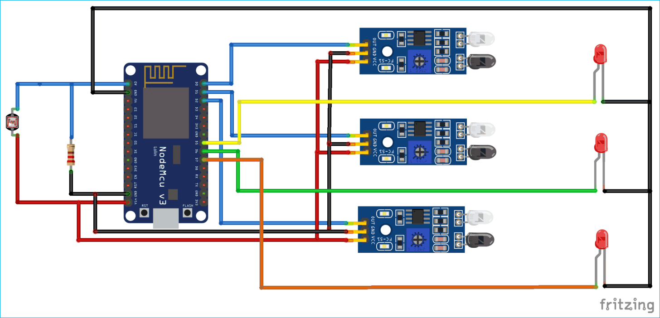

* 1. **Components**

IR Sensor

IR sensor is an electronic device which is used to detect objects by sensing infrared radiations reflected from the objects. It mainly consists of a transmitter **IR LED and a receiver photodiode**. When a specific positive voltage is applied across the transmitter LED it transmits the IR rays. If these rays fall on some object, then that object reflects back the IR rays which are received by the receiver photodiode. The receiver diode generates a voltage across its terminals which depend on the intensity of light reflected by the object.

LDR Sensor

LDR stands for **Light Dependent Resistor** also known as photo-resistor. LDR is sensitive to light and its resistance changes according to the intensity of light falling on it. When light incident on the LDR exceeds some threshold, it absorbs the photons and allows electrons to jump into the conduction band. LDR generates a variable resistance which depends on the intensity of light falling on it. It is mainly used in electric circuits like streetlights, alarm clocks, automatic brightness and contrast control etc.

**3.3 Justification**

We decided to use **IR proximity Sensor** compared to the other available sensors like ultrasonic proximity sensors and capacitive proximity sensors by considering factors like cost, performance over a long distance, suitability to detect complex objects.

We chose **LDR Sensor** compared to photodiode taking into consideration the cost and the fact that LDR can vary the light depending on the environments lighting conditions as compared to a photodiode which can only turn it on or off.

1. **Conclusion**

We were able to develop a perfectly working and executable model of the proposed system and have also added in a feature to help approximate the best speed limit for each road by measuring speeds to improve road safety. We are able to save a substantial amount of electricity especially in roads which are not widely used where lots of electricity is wasted though the roads are deserted. By using LED lights and our system which is a part of the smart city innovative system can help the environment by saving electricity and also improve road safety substantially. It is possible to deploy this model commercially and integrate it with the other smart city innovative available in various places to help make the world a better place.

1. **References**

* <https://ieeexplore.ieee.org/document/8326023>
* <https://www.researchgate.net/publication/323280626_Internet_Of_Things_Based_Intelligent_Street_Lighting_System_for_Smart_City>
* <https://ieeexplore.ieee.org/document/8326023>